TAMING THE MONKEY MIND
A MEDITATION WEEKEND WITH BHANTE AKALIKO
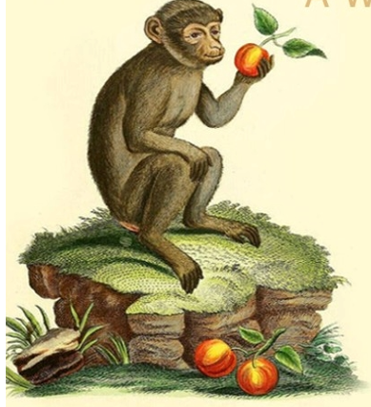

When our mind is untrained, our thoughts jump from one thing to the next, never stopping for a moment of peace. Meditation helps train the mind by identifying unhelpful thoughts and habits that cause us suffering.

SAT & SUN 14 – 15 MAY 9.30 AM- 4.30 PM
At Chrysalis Relaxation Centre 129 Mulgrave Rd Parramatta Park Cairns

CONTACT:
cairnsinsightmeditation@gmail.com

BYO lunch Sat & Sun
Tea/coffee provided both days
Attendance: by donation
Akāliko Bhikkhu is an Australian monk in the Theravada forest tradition. Bhante Akāliko first encountered Buddhism as a teenager and spent over twenty years practicing in different traditions before taking full ordination with Ajahn Brahm as his preceptor at Bodhinyana monastery in 2016. He currently resides with his long-term teacher, Bhante Sujato, at Lokanta Vihara (the Monastery at the End of the World) in Sydney, Australia.
Bhante Akāliko is the founder of Rainbodhi LGBTQIA+ Buddhist Community and a Buddhist chaplain at Western Sydney University. He is also on the board of directors of the Buddhist Council of NSW.

